
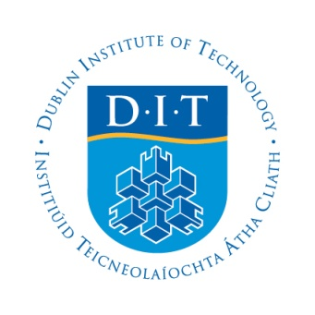
First International Conference on Building Integrated Renewable Energy Systems

6th- 9thMarch 2017
First Announcement and Call for Papers
Dublin Institute of Technology (DIT) Ireland

DIT Grangegorman
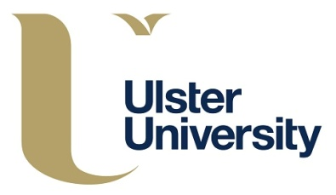

BIRES 2017

The organizing committee of BIRES 2017 invites you to submit papers to this first conference on building integrated renewable energy systems. For the first time, Building Integrated-Renewable Energy Systems will bring leading universities and industry together. The event provides an unparalleled networking opportunity, as well as the best way to learn about innovations and best practices for installation, performance, management and financial returns of these systems. The submitted papers will undergo peer reviewing by experts in the field. Accepted papers will be given the opportunity to be presented at the conference, included in the conference proceedings, and if selected, to be published in a Special Issues of the International journal, Renewable Energy. Along with the academic benefits, an industrial, poster session, social and cultural program will accompany the event that will ensure an enjoyable stay for all participants.

Conference Themes
Building Integration of:
Solar thermal systems (STS)
Photovoltaic / Thermal (PV/T)
Thermal Storage (TS)
Hybrid systems (HS)
Renewable and Sustainable Energy Systems

Key Dates
October 28, 2016: Abstract submission deadline
November 12, 2016: Abstract acceptance notification
December 19, 2016: Full paper submission deadline
January 13, 2017: Paper acceptance deadline
February 10, 2017: Final paper submission deadline
March 6th-9th, 2017: Conference

Organising Committee
Professor Brian Norton, Ireland, Chairman
Professor David Kennedy, Ireland, Deputy Chairman
Dr. Mervyn Smyth, UK
Dr. Jayanta Deb Mondol, UK
Dr. Aggelos Zacharopoulos, UK
Dr. Mick McKeever, Ireland
Donal Keys, Ireland
Tim O'Leary, Ireland

A one-page abstract in word format which can contain a representative figure or table, to be submitted to: https://bires2017.exordo.com/ on/or before October 28th 2016.
Website: http://dit.ie/dublinenergylab/events/bires/

Scientific Committee:

Professor Kalogirou Soteris, Chairman (Cyprus)  Dr. Aeleni Laura (Portugal)  Dr. Almeida Manuella (Portugal)  Professor Braganca Luis (Portugal)  Dr. Buonomano Annamaria (Italy)  Professor Cabeza Luisa (Spain)  Dr. Cappel Christoph (Germany)  Professor Chemisana Daniel (Spain)  Professor Chwieduk Dorota (Poland)  Professor Coronas Alberto (Spain)  Professor Cristofari Christian (France)  Dr. Deb Mondol Jayanta (UK)  Professor Farkas Istvan (Hungary)  Dr. Fedrizzi Roberto (Italy)  Dr. Florides Georgios (Cyprus)  Professor Ford Andy (UK)  Professor Georgiev Aleksandar (Bulgaria)  Professor Kennedy David (Ireland) | Professor Kilic Muhsin (Turkey)  Professor Krstic Furundzic Aleksandra (Serbia)  Dr. Lamnatou Chrysovalanto (Spain)  Dr. Leindecker Gerald (Austria)  Dr. Mateus Ricardo (Portugal)  Dr. McCormack Sarah (Ireland)  Dr. Monteiro Da Silva Sandra (Portugal)  Professor Norton Brian (Ireland)  Professor Norvaisiene Rosita (Lithuania)  Professor Notton Gilles (France)  Professor Palombo Adolfo (Italy)  Dr. Radulovic Jasna (Serbia)  Professor Savvides Andreas (Cyprus)  Dr. Smyth Mervyn (UK)  Professor Tripanagnostopoulos Yiannis (Greece)  Professor Visa Ion (Romania)  Dr. Wansdronk Rene (The Netherlands)  Dr. Zacharopoulos Aggelos (UK)

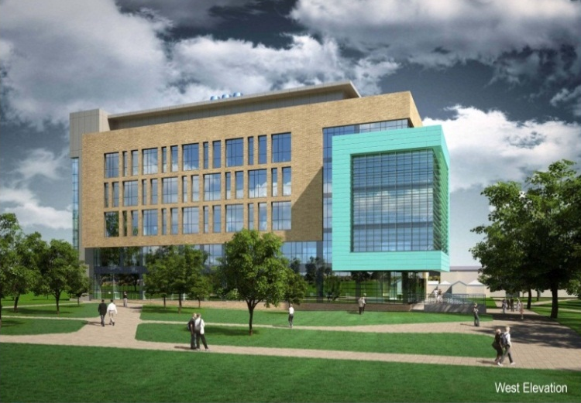
CONFERENCE ACTIVITIES:
- Welcome Reception: 6th March
- Keynote Speakers
- Paper presentations
- H2020 Research Collaboration meeting
- Poster Session
- Industry Exhibition
- Accepted papers will be published
in a Special Edition of
Renewable Energy Journal
- Social event

Local Accommodation:

Ashling Hotel | http://www.ashlinghotel.ie | +353 (0)1 677 2324
Phoenix Park Hotel | http://www.phoenixparkhotel.ie | +353 (0)1 677 2870
Castle Hotel | http://www.castle-hotel.ie | +353 (0)1 874 6949
Beresford Hotel | http://www.beresfordhotelifsc.com | +353 (0)1 813 4700
Maple Hotel | http://maplehotel.com | +353 (0)1 855 5442
Westin Dublin | http://www.thewestindublin.com | +353 (0)1 645 1000
Trinity City Hotel | http://www.trinitycityhotel.com | +353 (0)1 648 1000
Arlington Hotel O'Connell Bridge | http://www.arlington.ie | +353 (0)1 804 9100
Temple Bar Hotel | http://www.templebarhotel.com | +353 (0)1 677 3333
Best Western Plus Academy Plaza Hotel | http://www.academyplazahotel.ie | +353 (0)1 878 0666
Croke Park Hotel | https://www.doylecollection.com/hotels/the-croke-park-hotel | +353 (0)1 871 4444

Location
Grangegorman is the new campus of the Dublin Institute of Technology, one of the great success stories in developing Ireland’s growth over the last few years. Developments in technology, research, education and enterprise have formed the key cornerstones of this growth. Combined with its historical, social and cultural diversity, and surrounded by outstanding scenery, Dublin continues to be a vibrant and exciting city and joy to its citizens and visitors.

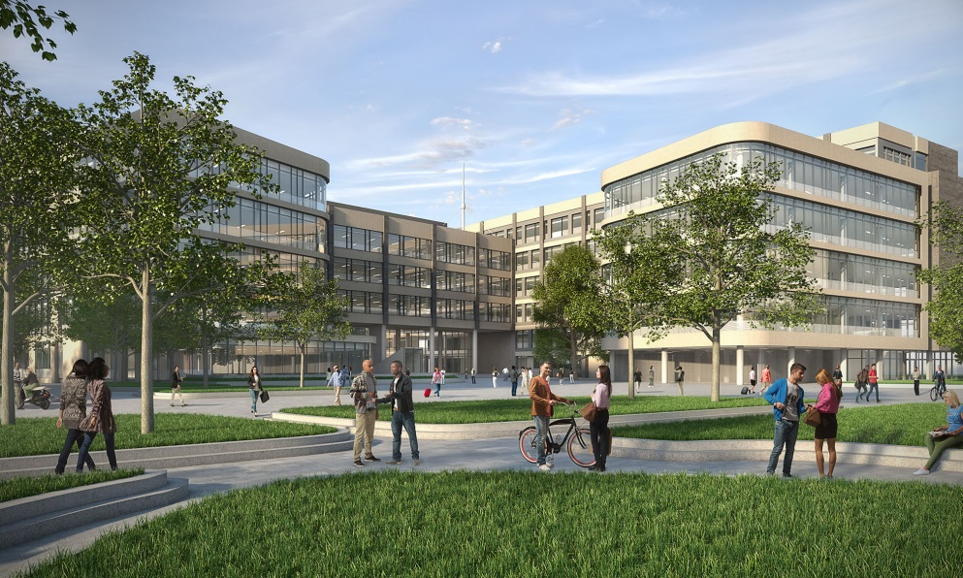

The Conference will be hosted in the Dublin Institute of Technology, Grangegorman campus, Dublin. The campus is close to numerous amenities and public transport. Just a short walk from O’Connell Street, the main street in Dublin, the visitor will find numerous historical buildings and monuments, city parks, and a range of shops and theatres, cinemas and art galleries. The lively Temple Bar area, Phoenix Park, Natural Museum and Smithfield is close by, hosting a wide variety of interest to visitors.

Registration and Fees:
Authors and Delegates: €325
Students and Posters: €200
COST Members: €100
Accompanied persons: €200

Those wishing to partake in the Conference Dinner, the following costs apply:
Gala Dinner: €70 (this applies to COST members also)

Contacts and Website:
Refer to the conference web site http://dit.ie/dublinenergylab/events/bires/ for Conference Fees, registration details and paper layout.

Submit your abstract: by visiting the Ex Ordo abstract submission system (you will be requested to set up an account first): https://bires2017.exordo.com/
david.kennedy@dit.ie

